MINI PROJECT REPORT

**On**

**Food Ordering Web Application**

Submitted by

**Vineet Rathor**

Roll No: 171500382

**Saurabh Singh**

Roll No: 171500302

**Rajeev Ranjan Chaturvedi**

Roll No: 171500253

Submitted to

**Mr. Pankaj Kapoor**

**Technical Trainer**

Department of Computer Engineering & Applications

**Institute of Engineering & Technology**



**GLA University**

**Mathura- 281406, INDIA**

**November, 2019**

**Department of Computer Engineering and Applications**

**GLA University, Mathura**

**17 km. Stone NH#2, Mathura-Delhi Road, P.O. – Chaumuha,**

**Mathura – 281406**



**Declaration**

*We hereby declare that the work which is being presented in the Mini Project Titled:* ***“Food Ordering Web Application”,*** *in partial fulfillment of the requirements for Mini-Project LAB, is an authentic record of our own work carried under the supervision of* ***Mr. Pankaj Kapoor, Technical Trainer, GLA University, Mathura****.*

**Vineet Rathor**

**Saurabh Singh**

**Rajeev Ranjan Chaturvedi**



**Department of Computer Engineering and Applications**

**GLA University, Mathura**

**17 km. Stone NH#2, Mathura-Delhi Road, P.O. – Chaumuha,**

**Mathura – 281406**

**CERTIFICATE**

*This is to certify that the project entitled* ***“Food Ordering Web Application”*** *carried out in Mini Project – Lab is a bonafide work done by* ***Vineet Rathor(171500382), Saurabh Singh(171500302)*** *and* ***Rajeev Ranjan Chaturvedi(171500253)*** *and is submitted in partial fulfillment of the requirements for the award of the degree Bachelor of Technology (Computer Science & Engineering).*

**Signature of Supervisor:**

**Name of Supervisor: Mr. Pankaj Kapoor**

**Date: 20/11/2019**

# ACKNOWLEDGEMENT

It gives us a great sense of pleasure to present the report of the B. Tech Mini Project undertaken during B. Tech. Third Year. This project in itself is an acknowledgement to the inspiration, drive and technical assistance contributed to it by many individuals. This project would never have seen the light of the day without the help and guidance that we have received.

Our heartiest thanks to Dr. (Prof). Anand Singh Jalal, Head of Dept., Department of CEA for providing us with an encouraging platform to develop this project, which thus helped us in shaping our abilities towards a constructive goal.

We owe special debt of gratitude to Mr. Pankaj Kapoor, Technical Trainer, Department of CEA, for his constant support and guidance throughout the course of our work. His sincerity, thoroughness and perseverance have been a constant source of inspiration for us. He has showered us with all his extensively experienced ideas and insightful comments at virtually all stages of the project & has also taught us about the latest industry-oriented technologies.

We also do not like to miss the opportunity to acknowledge the contribution of all faculty members of the department for their kind guidance and cooperation during the development of our project. Last but not the least, we acknowledge our friends for their contribution in the completion of the project.

**Vineet Rathor**

**Saurabh Singh**

**Rajeev Ranjan Chaturvedi**

**ABSTRACT**

Online Food Ordering System is a part of e-commerce. E-commerce or business through net means distributing, buying, selling, marketing, and servicing of products or services over electronic systems such as the Internet and other computer networks.

The online food ordering system gives restaurants the ability to increase sales and expand their business by giving customers the facility to order food online. With an online restaurant menu ordering system, customers can place orders online 24 *7. Thus it is a simple, fast and convenient food ordering system giving an edge over the competition at an affordable price.

Online ordering system greatly simplifies the ordering process for both the customer and the restaurant. System presents an interactive and up-to-date menu with all available options in an easy to use manner. Once the order is placed it is entered in the database and retrieved in pretty much real time. This allows Restaurant Employees to quickly go through the orders as they are received and process all orders efficiently and effectively with minimal delays and confusion.

**Table of Contents**

|  |  |
| --- | --- |
| Declaration | ii |
| Certificate | iii |
| Acknowledgment | iv |
| Abstract | v |
| 1. **Introduction** | **1** |
| 1.1 Purpose……………………………………….............. | 1 |
| 1.2 System Overview.…………………………………….. | 1 |
| 1.3 Motivation…………………………………………….. | 1 |
| 1.4 Basic Terms Used…………………………………….. | 2 |
| 1. **Software Requirements & Analysis** | **4** |
| 2.1 Problem Statement……...……………………………... | 4 |
| 2.2 Software Requirements………………………………... | 4 |
| 2.3 Hardware Requirements………………………………. | 9 |
| 2.4 Modules & its Functionalities…………………………. | 10 |
| 1. **Software Design** | **21** |
| 3.1 DFD Data Flow Diagram……………………………... | 21 |
| * 1. ER Diagram………………………..………………….. | 22 |
| 1. **Implementation & User Interface** | **23** |
| 4.1 How to order a Food Item…………………………...... | 23 |
| 1. **Conclusion** | **25** |
| **References/Bibliography** | **25** |

**CHAPTER 1**

**INTRODUCTION**

This section gives a scope of description and overview of everything included in this project report. Also, it includes the system overview with goal and vision.

* 1. **PURPOSE**

The purpose of this document is to give detailed information regarding this Mini Project labeled “Food Ordering Web Application”. It will illustrate the complete declaration of the application developed. In addition to this, it gives detailed description of the implementation of the system along with system constraints. This document is primarily intended to give an overview to anyone of how this application works and is beneficial to the changing world. Also gives an overview of the use of different technologies in making this project.

* 1. **SYSTEM OVERVIEW**

Online Food Ordering is a system made for the automation mode to deliver the food to the customer just by selecting the type of food and doing payment and the food will be delivered to the customer’s respective place. Details of the customers are stored in the database so that they can login easily and avail the benefit of ordering the food. After that, the user just needs to select the searched item and then select the quantity and then is redirected to payment module where user pays the amount and then food will be delivered to his/her house address.

* 1. **MOTIVATION**

The previous way of food ordering through phone calls included many problems like, the staff of the Restaurant should speak to the different people talking with different accents, and sometimes there would be the background disturbances. By all these activities, food ordering might go false. But now because of Order Online Food Delivery, all the above difficulties are solved. Nowadays people do not have time to go outside for food, rather they prefer online ordering. It allows your customers to pay cash on receiving food at their door step. It helps to

increase your brand credibility. Delicious food can be served with online food ordering system that helps you to acquire new customers.

* 1. **BASIC TERMS USED**

**1.4.1 Npm –** Npm is a package manager for the JavaScript programming language. It is the default package manager for the JavaScript runtime environment Node.js. It consists of a command line client, also called Npm, and an online database of public and paid-for private packages, called the Npm registry.

**1.4.2 HTML –** Hypertext Markup Language is the standard markup language for documents designed to be displayed in a web browser. It can be assisted by technologies such as Cascading Style Sheets and scripting languages such as JavaScript.

**1.4.3 CSS -** Cascading Style Sheets is a style sheet language used for describing the  
presentation of a document written in a markup language like HTML. CSS is a cornerstone technology of the World Wide Web, alongside HTML and JavaScript.

**1.4.4 JavaScript –** JavaScript, often abbreviated as JS, is a high-level, interpreted scripting language that conforms to the ECMAScript specification. JavaScript has curly-bracket syntax, dynamic typing, prototype-based object-orientation, and first-class functions.

**1.4.5 Bootstrap -** Bootstrap is a free and open-source CSS framework directed at responsive, mobile-first front-end web development. It contains CSS and JavaScript-based design templates for typography, forms, buttons, navigation and other interface components.

**1.4.6 Mongoose -**Mongoose provides a straight-forward, schema-based solution to model

your application data. It includes built-in type casting, validation, query building, business logic hooks and more, out of the box.

**1.4.7 EJS –** EJS is a simple templating language that lets you generate HTML markup with plain JavaScript. No religiousness about how to organize things. No reinvention of iteration and control-flow. It's just plain JavaScript.

**1.4.8 Socket.io -** Socket.IO is a JavaScript library for real-time web applications. It enables real-time, bi-directional communication between web clients and servers. It has two parts: a client-side library that runs in the browser, and a server-side library for Node.js. Both components have a nearly identical API.

**1.4.9 Express.js –** Express.js, or simply Express, is a web application framework for  
Node.js, released as free and open-source software under the MIT License. It is designed for building web applications and APIs. It has been called the de facto standard server  
framework.

**CHAPTER 2**

**SOFTWARE REQUIREMENTS & ANALYSIS**

**2.1 PROBLEM STATEMENT**

Nowadays everyone is having busy schedule whether it is urban area or rural. But talking specifically about the urban areas and deeply about the big cities, people out there are so busy in their life that they don’t get enough of time to have their meals properly. As these days women are no less than men, in any field. So in big cities even wives are working women, therefore mostly the small families manage to have their food ordered from somewhere, as they lack time. Not only is this the case, if we talk about the children in the modern era they like only fast food or something from the outside. But they ignore eating homemade meals.

So food ordering system these days has one of the fastest growing markets, though being a new idea. In this project we have developed something like the same to earn from and serve the nation in a much better way possible. Nowadays, people are more regular to dine-in at restaurant for their meals. The online food ordering system provides convenience for the customers that are nothing special but the general busy people of the society. It overcomes the demerits of the manual hotel or mess system and the old fashioned queuing system. This system enhances the readymade of foods than people.

**2.2 Software Requirements:**

**2.2.1 Node.js:**

Node.js is an open-source, cross JavaScript code outside of a browser. Node.js lets developers use JavaScript to write command line tools and for server dynamic web page content before the page is sent Node.js represents a "JavaScript everywhere" paradigm, development around a single programming language, rather than different languages for server- and client-side scripts.

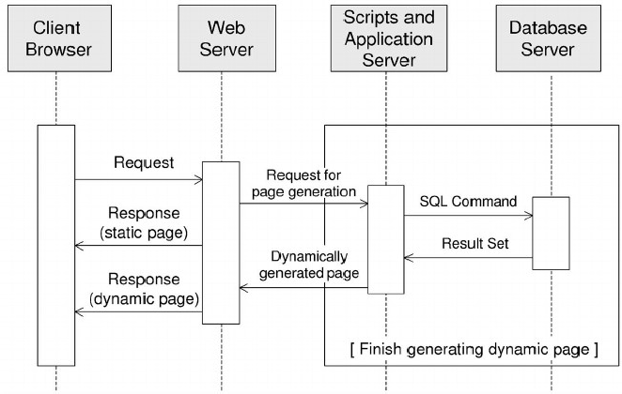

Figure: 2.1: Traditional Server

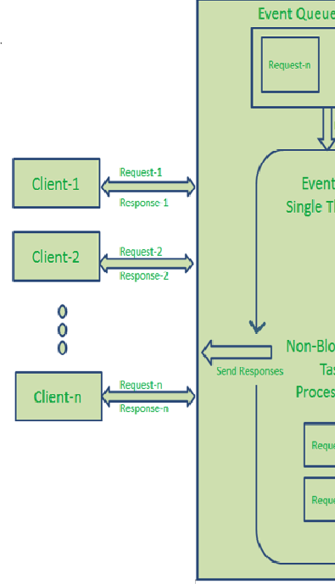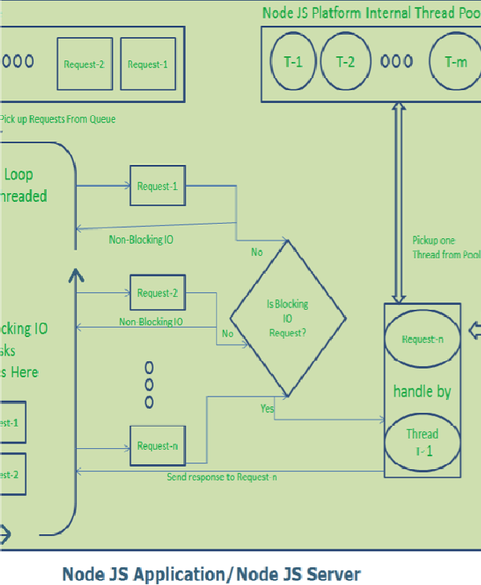

Figure: 2.2: Node.js Server

**2.2.2 Express.js:**

Although Node is capable of independently act as a web server, there are frameworks  
designed to make it more powerful and efficient minimal, and has several applications built

for it. Express was chosen for several reasons among them are: Express makes it possible to build an HTTP server very of node.js and its makes the RESTFUL API’s very simple.  
Express supports middleware which are functions called in a sequential order on a request or response. For example, a middleware I am using is body parser, which parses the body of incoming HTTP requests with a form submission. This allows me to access the parameter the request directly. Middleware can do anything, and they end with next(), which calls the next middleware. Routes are Express’s way to handle incoming requests on a certain URL. Express after detecting the incoming requests directs it to a specific Routing JavaScript file that handles all the logic associated with that URL.

**2.2.3 Npm:**

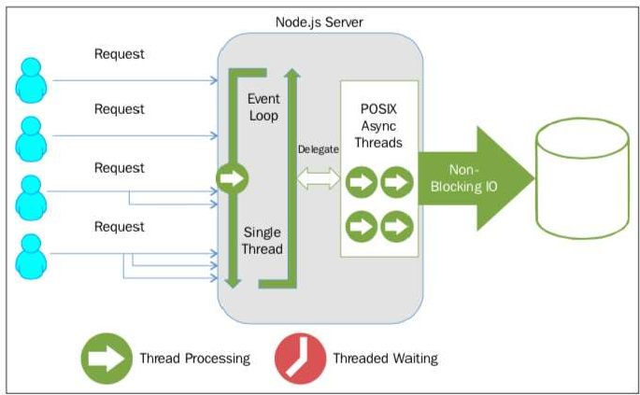The Node Package Manager is based on JavaScript's Npm. A built-in module that supports package management, it can be used to easily download and install modules for a Node application. Moreover, Node already has many packages and libraries developed to work on top of it.

Figure: 2.3: Node.js event loop single thread

**2.2.4 MongoDB:**

MongoDB is a cross-platform document-oriented database program. Classified as a NoSQL database program, MongoDB uses JSON-like documents with schema. MongoDB is developed by MongoDB Inc.

MongoDB supports field, range query, and regular expression searches. Queries can return specific fields of documents and also include user-defined JavaScript functions. Queries can also be configured to return a random sample of results of a given size.

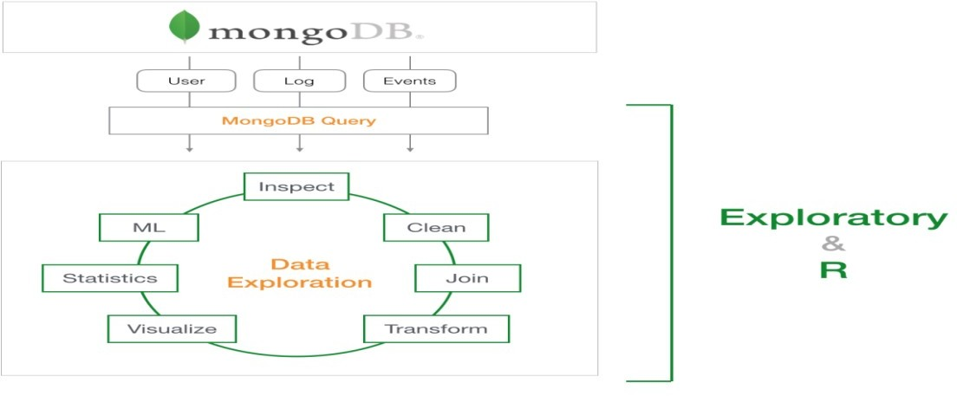

Figure 2.4: MongoDB Block Diagram

**2.2.5 Web Browser:**

A web browser, or simply "browser," is an application used to access and view websites. Common web browsers include Microsoft Internet Explorer, Google Chrome, Mozilla Firefox, and Apple Safari.

The primary function of a web browser is to render HTML, the code used to design or "mark up" web pages. Each time a browser loads a web page, it processes the HTML, which may include text, links, and references to images and other items, such as cascading style sheets and JavaScript functions. The browser processes these items, then, renders them in the browser window.

**2.2.6 Visual Studio Code:**

Visual Studio Code is a lightweight but powerful source code editor which runs on your desktop and is available for Windows, MacOS and Linux. It comes with built-in

Support for JavaScript, Typescript and Node.js and has a rich ecosystem of extensions for other languages (such as C++, C#, Java, Python, PHP, Go) and runtimes (such as .NET and Unity).

Visual Studio Code is an editor first and foremost, and includes the features you need for highly productive source code editing. This topic takes you through the basics of the editor and helps you get moving with your code.

**2.2.7 Socket.io:**

Socket.IO is a library that enables real-time, bidirectional and event-based communication between the browser and the server. It consists of:

• A Node.js server: Source | API

• A JavaScript client library for the browser (which can be also run from Node.js): Source | API

Its main features are:

Reliability

Auto-reconnection support Disconnection detection

Multiplexing support, Basic code in socket.io is: -

var io = require('socket.io')(80);

var cfg = require('./config.json');

var tw = require('node-tweet-stream')(cfg); tw.track('socket.io');

tw.track('javascript');

tw.on('tweet', function(tweet){io.emit('tweet', tweet);}

**2.3Hardware Requirements**

* + - 500 GB Memory
    - 2GB RAM
    - i3 processor

**2.4 Modules & its Functionalities**

**2.4.1 Signup Module:**

We have made a Sign Up section which comes as a pop up when clicked on the Sign Up option given in the navigation bar at the top ,a little of animation is used to show the contents of Sign Up . User gets certain benefits when signing in as then only user can book the food item. There are 4 fields in Sign Up form which user has to fill in order to sign in and then those values are stored in the MongoDB database by the help of backend connectivity.

On signing in new page loads where there are no options of Sign Up and Login and there at the right top corner of the Navigation Bar user can see his given username.

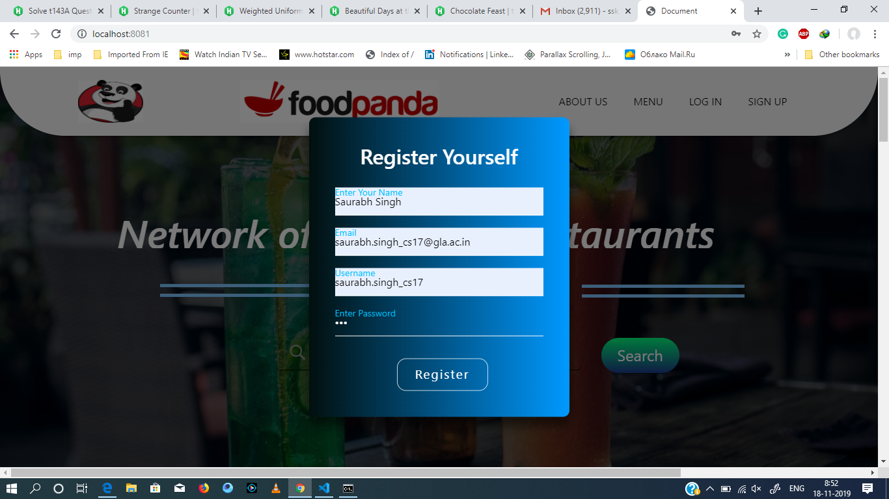

Figure 2.5 Sign-up Form

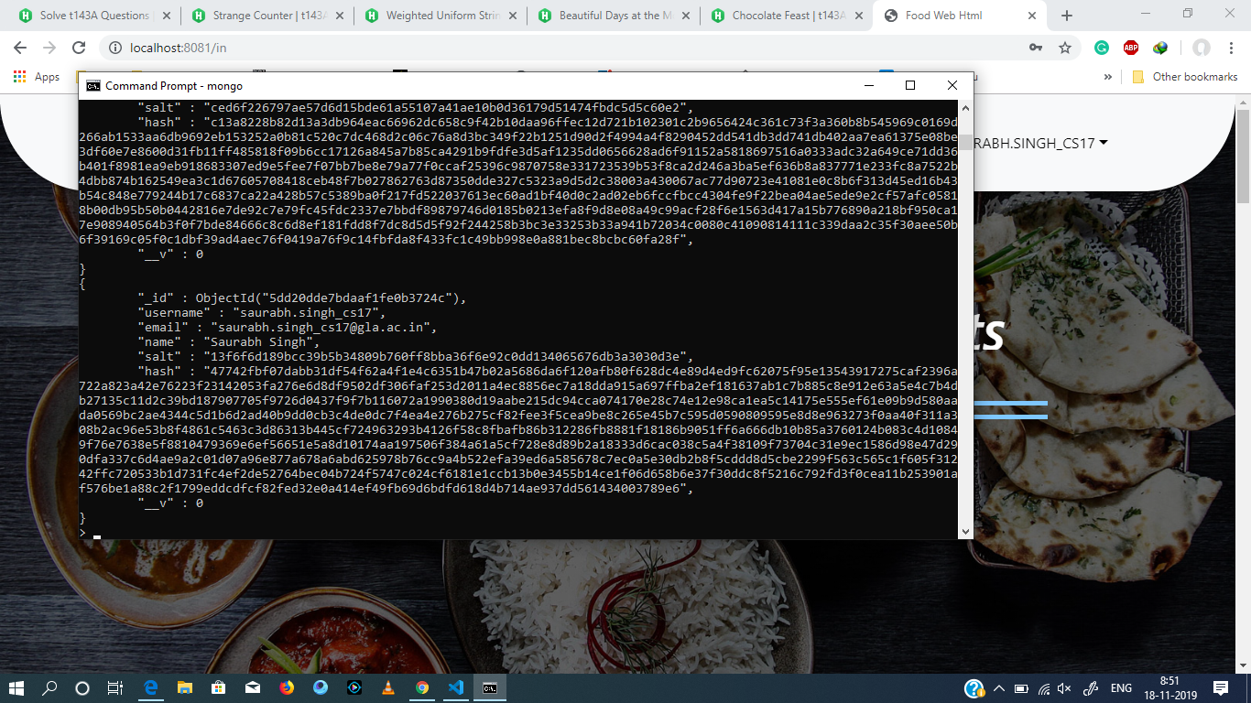

Figure 2.6 Value in Database after sign up

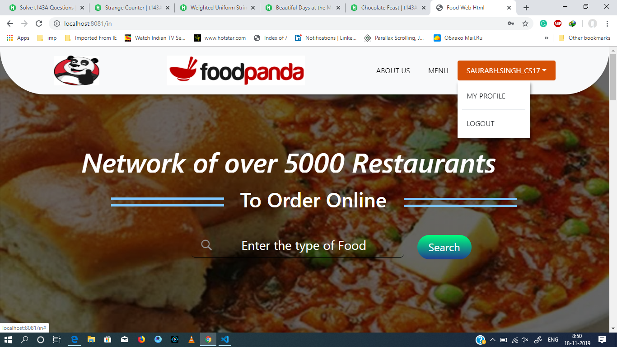

Figure 2.7 Username visible at the top right corner

**2.4.2 Login Module:**

Made a Login Form which comes as a popup when user clicks on the Login Option in the navigation bar and only those users who have previously signed in can only Login as there given credentials are stored in the database and for the rest will show error.

On correctly entering the username and password, user is redirected to the Logged In page where he/she can see his username on the top.

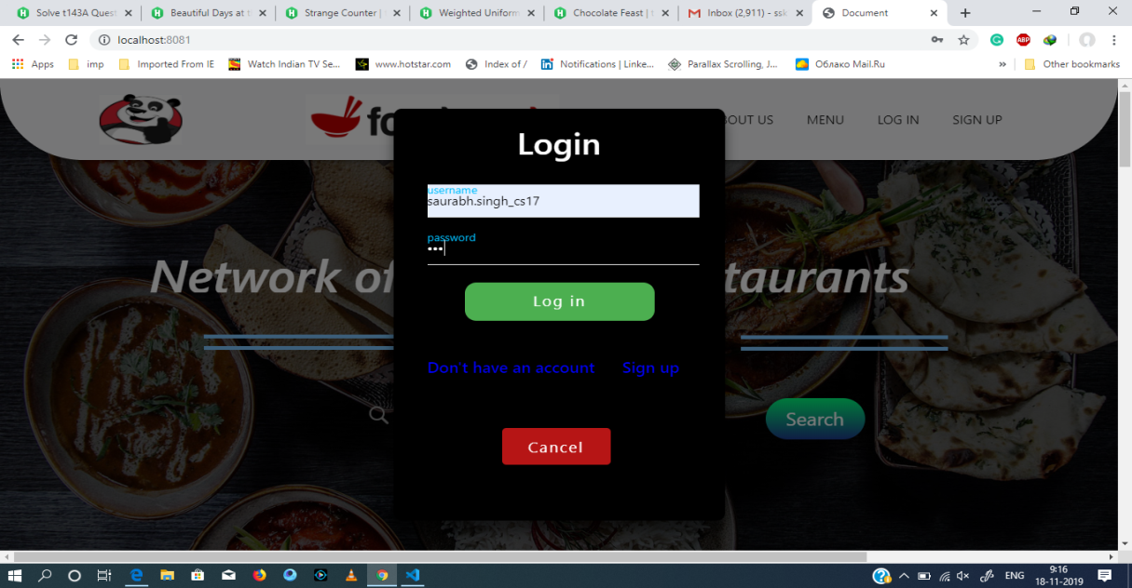

Figure 2.8 Log in form with the sign up values

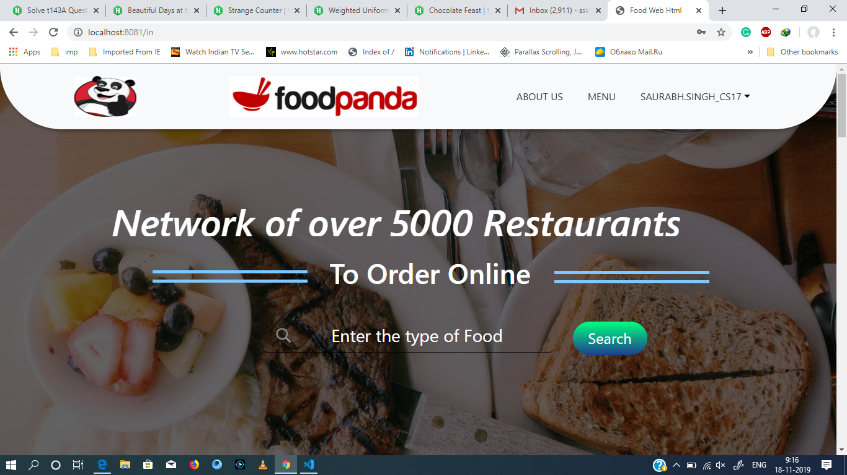

Figure 2.9 Username at the top right corner

**2.4.3 Feedback Module:**

We have made a feedback page which is not visible initially but there is a segment made in the About Us section where when user clicks on the Click Me button given below the line “Give your feedback” then user is directed to the Feedback Form which was earlier not seen anywhere but now can be seen and this all is done without creating another page, this is done to reduce the no. of pages in the website.  
User can then enter his name, email , phone no. and the message and that will be saved in database on clicking the submit button and after that page refreshes and user lands back to his/ her original position i.e. logged in page if logged in otherwise normal page.

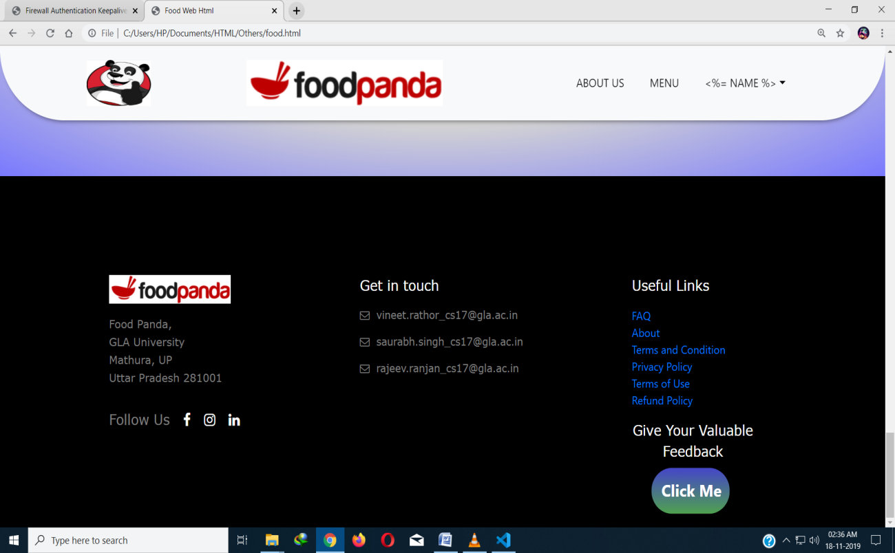

Figure 2.10 Feedback Option in About Us section

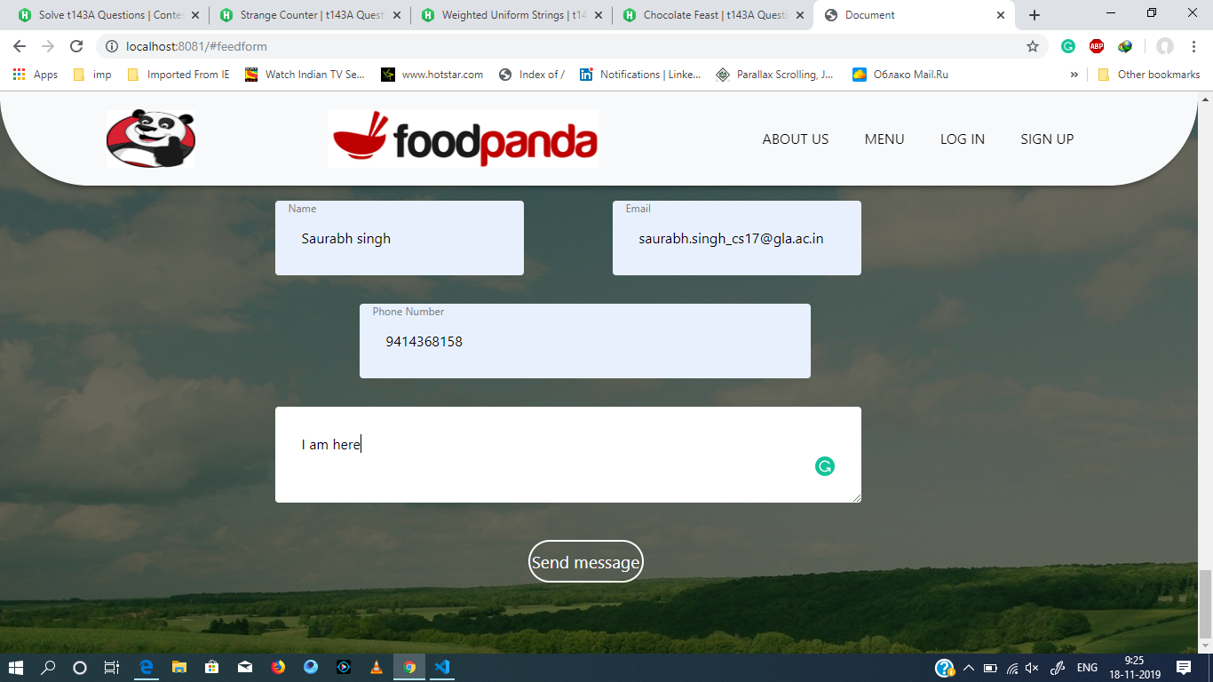

Figure 2.11 Feedback Section with entered values

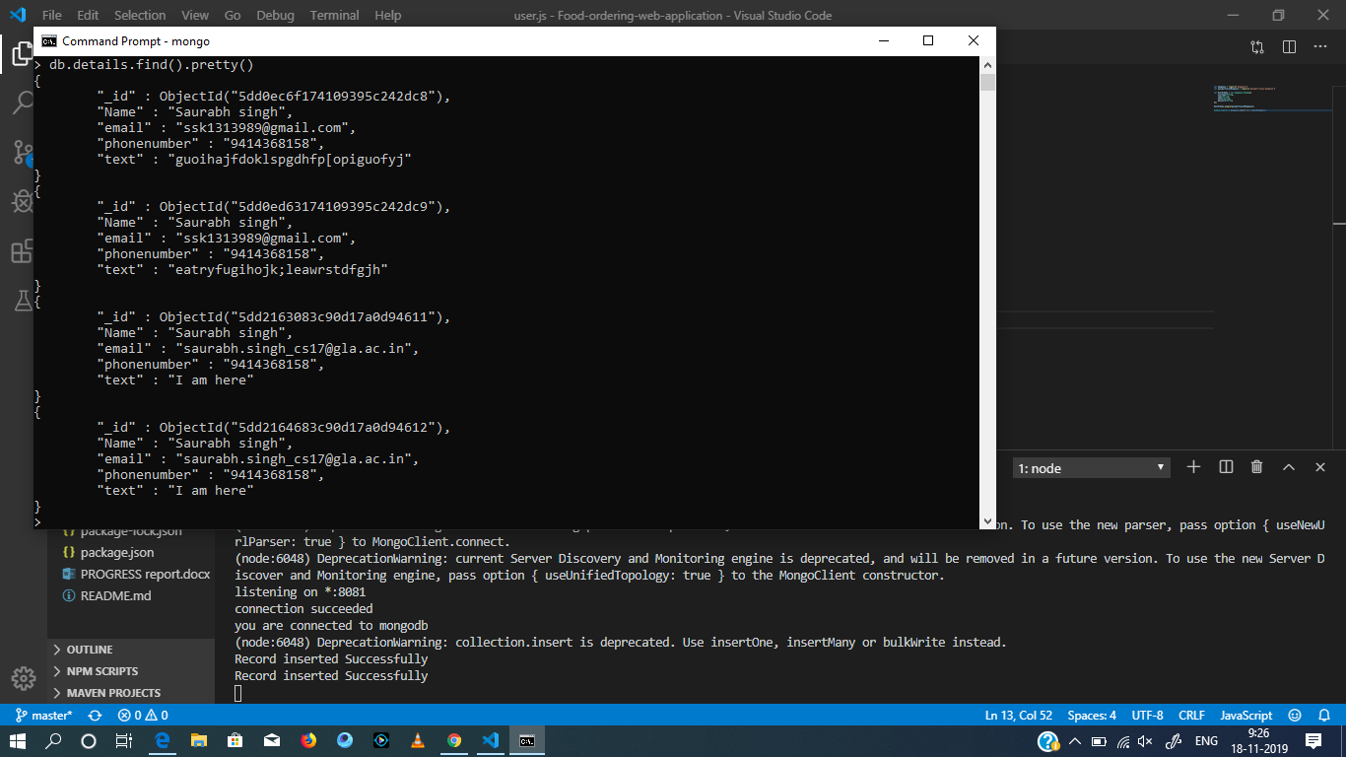

Figure 2.12 Entered Feedback valued in database

**2.4.4 Menu Module:**

In this Menu module, We have added 4 types of food items as a prototype as to what Menu will look like, User can directly reach the menu by clicking on the Menu option provided in the Navigation Bar or he can search for the type of food (like pizza, burger etc.) in the search bar present on the Main page and then user will be redirected to the menu section and there user can select the food item which he wants to order and if user is not logged in then user will given an alert that he is not logged in and Login popup will automatically open and when logged in and user clicks on the order now option then user will be redirected to the Ordering cart.

Bootstrap grid was used to make the structure of the menu section in order to make this look responsive and when window is resized then it will adjust the width and height itself so that items don’t get overlap.

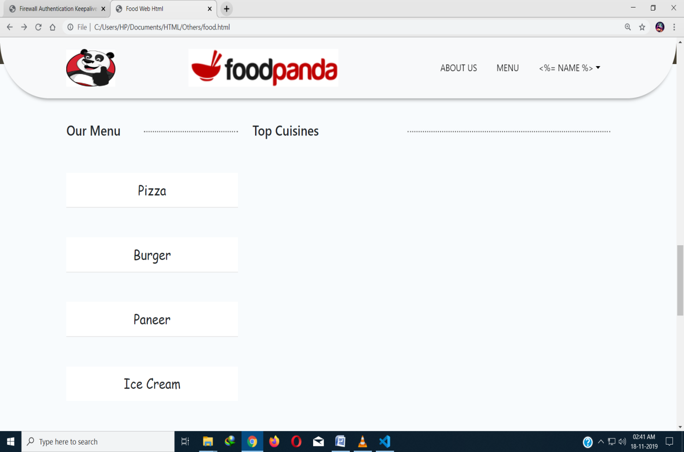

Fig 2.13 Menu Section

**2.4.5 Ordering Cart Module:**

In this module, user can order can a specific food or can order more food and the food information will be displayed on the cart with the total price including that of previous item and when clicked on proceed to payment button then user will be redirected to the payment page.

This section will not be visible to the normal visiting users but to only those who are logged in and that too when they click on the food item to Order Now and then will be visible afterwards. Basic JavaScript is taken is use for calculating the total price or cancelling an item from the cart or displaying the name of the Food Item, Its Hotel name as well its price.

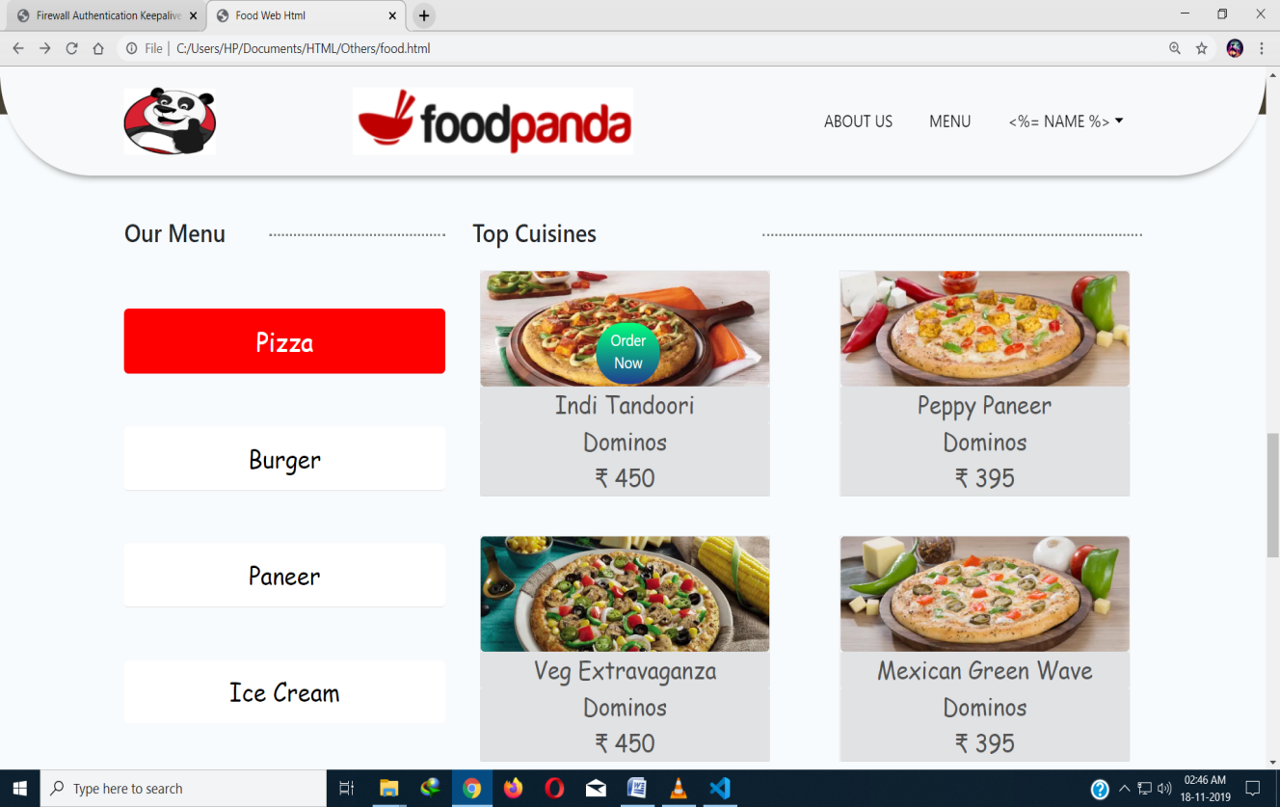

Fig 2.14 on clicking this button will display Ordering Cart if logged in

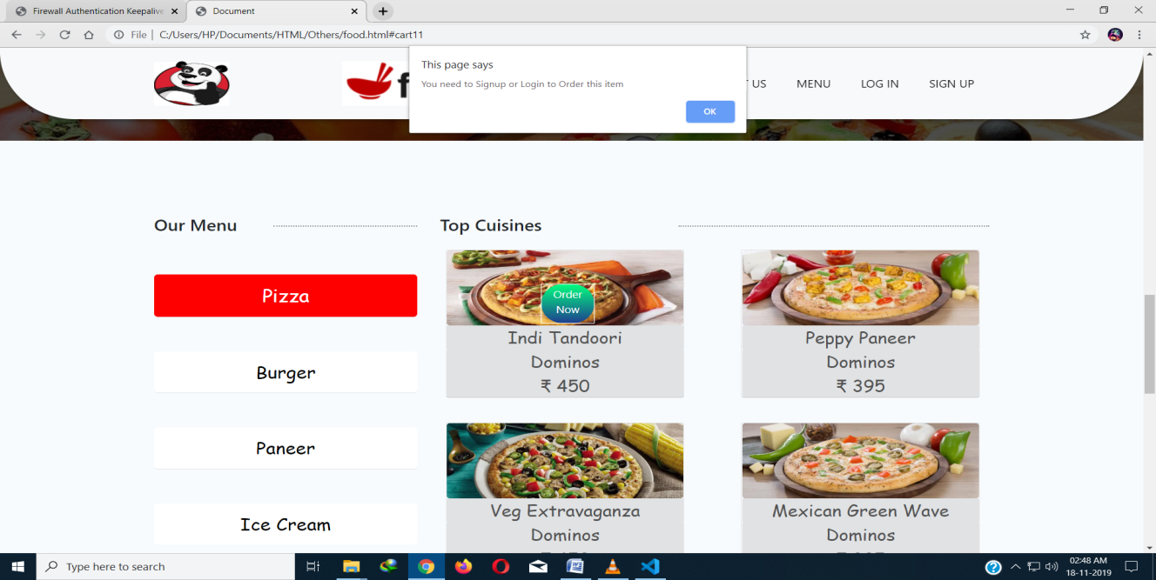

Figure 2.15 Alert message for not logged in user

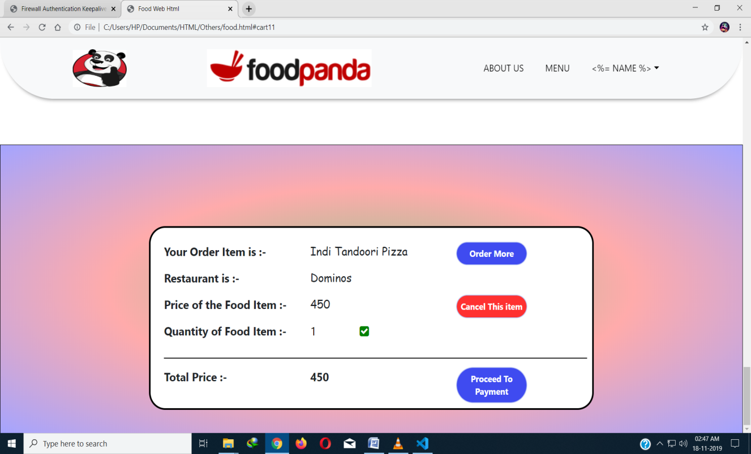

Figure 2.16 Ordering Cart Section

**2.4.6 About Us Module:**

In this module, Information about the site is given as well as the terms and policies and some other information, User can reach this section by either scrolling or by clicking on the About Us option given in the Navigation Bar.

Feedback Option is given in this module where user can give his valuable feedback on clicking the “Click Me” button

Some basic animations are also added in this section to look more attractive which are seen when user scroll to this section.

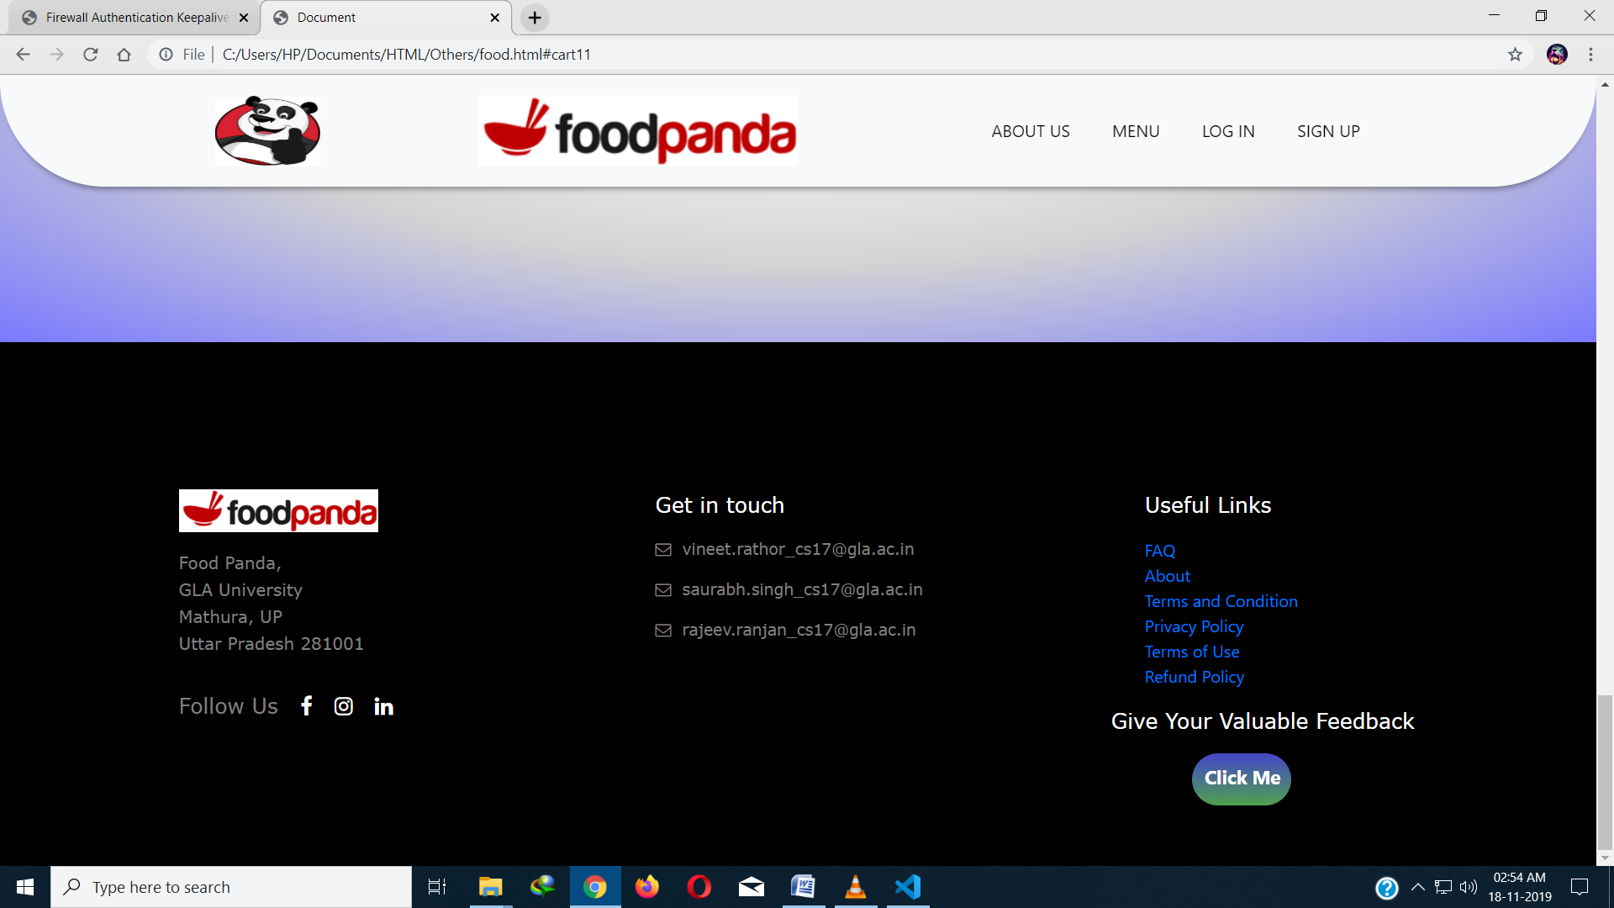

Figure 2.17 About Us Section

**2.4.7 Profile Page Module:**

This module is available only for the logged in users and to go this page, user can click on the dropdown arrow which is present on the right of his/her username and then dropdown section opens which has two options :- My Profile & Log Out.

On clicking the “My profile" user is redirected to the profile page where his information which he entered during Sign Up will be displayed as well as there will option to add more information (like Date of Birth, Gender, Address, Bio etc..) and that information will be stored in the Database.

**2.4.8 Main Page Module:**

This is the main page which will be visible to every visiting person and this contains all the other sections directly or indirectly, It has Navigation Bar at the top , then there is animated text then there is search button below which there is another portion giving information to the user how to order which is also animated and then there is portion of favorite items below which we can see the menu section and then there is a Image having Animated Content and in the last there is About us section.

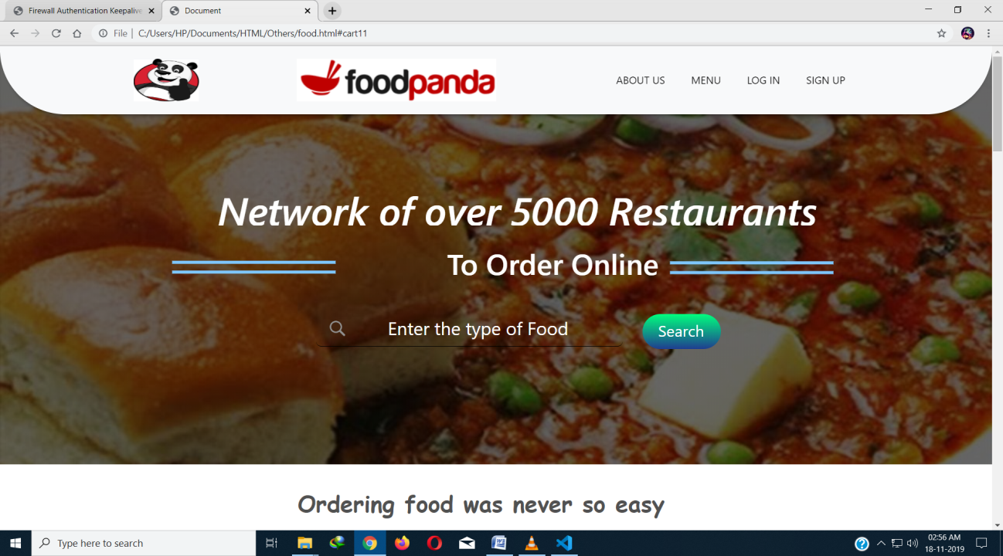

Figure 2.18 About Us Section

**CHAPTER 3**

**SOFTWARE DESIGN**

The project design includes DFDs, UML diagrams which consists of Use case diagrams, Database including tables details and sequence diagrams.

**3.1 DFD Data Flow Diagram**

It is a diagram of Authentication process which is a part of our project. In it user will enter his/her information to register, if the account already exists he/she will be ab e to do login directly without doing registration.

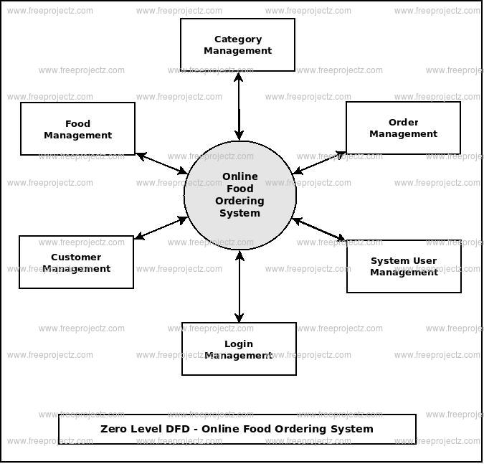

Figure 3.1 Zero Level DFD

**3.2 ER Diagram**

An Entity Relationship (ER) Diagram is a type of flowchart that illustrates how “entities” such as people, objects or concepts relate to each other within a system. ER Diagrams are most often used to design or debug relational databases in the fields of software engineering, business information systems, education and research. Also known as ERDs or ER Models, they use a defined set of symbols such as rectangles, diamonds, ovals and connecting lines to depict the interconnectedness of entities, relationships and their attributes. They mirror grammatical structure, with entities as nouns and relationships as verbs.ER diagrams are related to data structure diagrams (DSDs), which focus on the relationships of elements within entities instead of relationships between entities themselves.

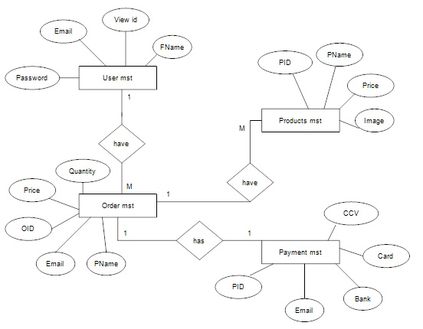

Figure 3.2 ER diagram

**CHAPTER 4**

**IMPLEMENTATION AND USER INTERFACE**

**4.1 How to Order a Food Item**

**4.1.1 Log In or Sign Up if already have an account**

Click on the Sign Up option in the navigation bar or Log in directly if already having an account.

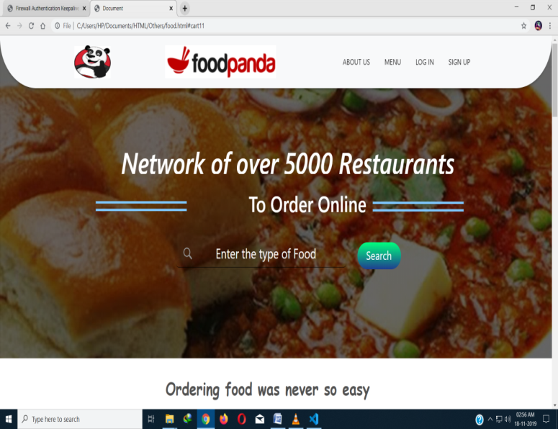 (a)

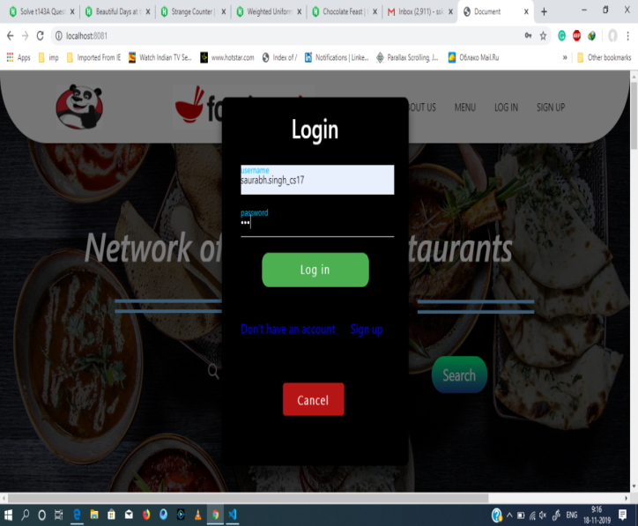 (b)

Figure 4.1 (a) Front Page (b) Login Page

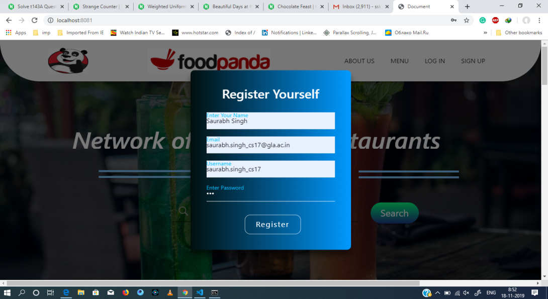

Figure 4.2 Sign Up page

**4.1.2 Head Over to menu section and click on order now button of item**

You can reach menu section either by search bar or by clicking the option provided in the Navigation bar and when user hover over an item then user can see the Order Now, and on clicking that button will take him to the Ordering Cart section where he can either order more or can proceed to payment by clicking on proceed to payment option and pay the amount.

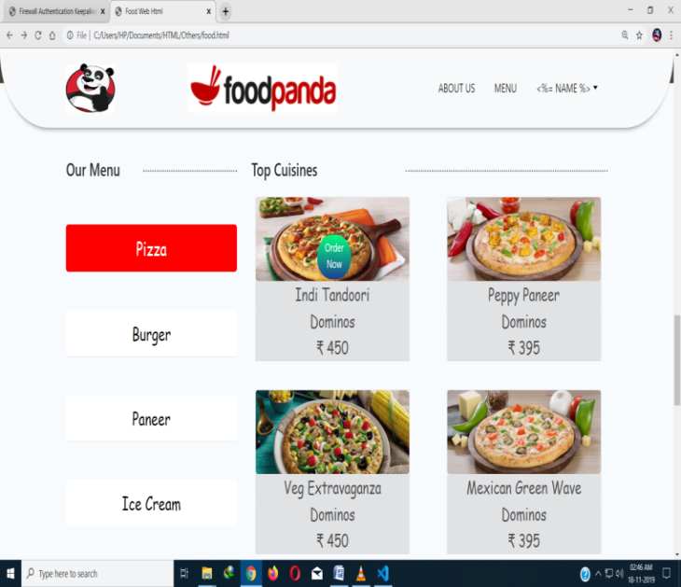 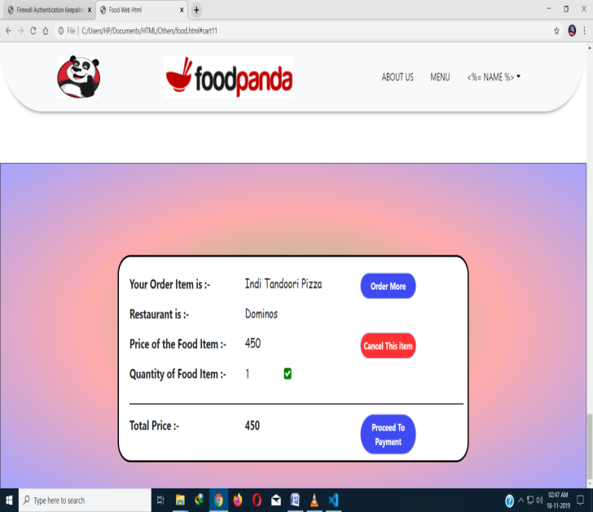

(a) (b)

Figure 4.3 (a) Menu Section (b) Ordering Cart

**CHAPTER 5**

**REFRENCES/BIBILIOGRAPHY**

## <https://nodejs.org/en/>

## https://[www.npmjs.com/](http://www.npmjs.com/)

## <https://expressjs.com/>

## <https://socket.io/>

## https://[www.w3schools.com/html/](http://www.w3schools.com/html/)

## https://[www.w3schools.com/css/](http://www.w3schools.com/css/)

## https://[www.w3schools.com/js/lt.asp](http://www.w3schools.com/js/lt.asp)

## https://[www.mongodb.com/](http://www.mongodb.com/)